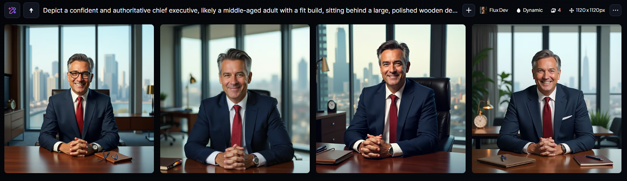

“Depict a confident and authoritative chief executive, likely a middle-aged adult with a fit build, sitting behind a large, polished wooden desk in a modern, sleek office with a city skyline visible through the floor-to-ceiling windows, wearing a tailored navy blue suit, crisp white dress shirt, and a red tie, with a subtle smile on their face, revealing a hint of confidence and leadership, their dark brown hair styled neatly, with a few grey strands, and a gentle glow on their light brown skin, their eyes gleaming with a sense of accomplishment, their hands clasped together in front of them, with a few pens and a leather-bound notebook lying on the desk, surrounded by subtle hints of luxury and sophistication, such as a minimalist clock and a small, elegant lamp.”



“A confident and authoritative chief executive sitting behind a large, polished mahogany desk in a sleek, modern office with floor-to-ceiling windows, wearing a tailored navy blue suit, crisp white dress shirt, and a subtle silver tie, with a hint of grey hair at the temples and a warm, approachable smile, gaze directed at the viewer, with a subtle expression of determination and leadership, against a blurred background of city skyscrapers, with a few scattered papers and a silver pen holder on the desk, and a slight sense of natural light casting a warm glow on the scene.”

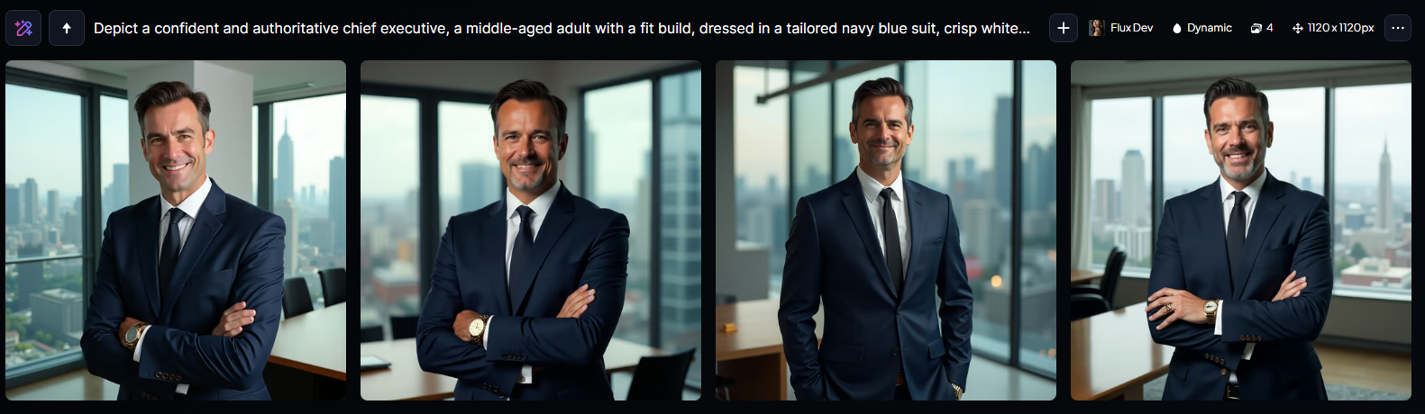

“Depict a confident and authoritative chief executive, a middle-aged adult with a fit build, dressed in a tailored navy blue suit, crisp white shirt, and a slim black tie, standing in a modern, sleek, and minimalist office with a large window overlooking a bustling cityscape, with a hint of sunlight reflecting off the polished wooden desk in the foreground, the CEO's face showcasing a mix of determination and approachability, with a strong jawline, piercing brown eyes, and a subtle, professional smile, their dark brown hair stylishly trimmed and gelled, and a few wrinkles on the forehead hinting at a seasoned and experienced leader, with a few subtle, yet tasteful, gold accessories and a quality timepiece on their wrist, exuding an aura of professionalism, sophistication, and leadership.”